ECOMMERCE WEB APPLICATION DEVELOPMENT AT

BANGLA SOFT COMPUTER.

SAGAR SAHA



ECOMMERCE WEB APPLICATION DEVELOPMENT AT

BANGLA SOFT COMPUTER.

SAGAR SAHA

A report submitted

In partial fulfillment of the requirements

For the degree of

Bachelor of Science in Computer Science and Engineering

Submitted to

Satyaki Das

Lecturer, Department of Computer Science and Engineering

UNIVERSITY OF LIBERAL ARTS BANGLADESH

Dhaka, Bangladesh

23 April 2020

DECLARATION

I declare that this “ECOMMERCE WEB APPLICATION DEVELOPMENT” report is the result of my own research, unless stated otherwise in the references. The report was not accepted for any degree and was not simultaneously submitted as a candidate for another degree.

Signature :

**Name :** SAGAR SAHA

**ID :** 142014024

**Date**  **:** April 23, 2020

CERTIFICATE OF APPROVAL

The project report entitled “ECOMMERCE WEB APPLICATION DEVELOPMENT” is submitted to the Department of Computer Science and Engineering at University of Liberal Arts Bangladesh (ULAB) in partial fulfillment of the requirements for the degree of Bachelor of Science**.**

Dated: April 23, 2020

|  |  |
| --- | --- |
|  | |
| **Md Abdul Mottalib,Phd**  Professor & Head of Department  Computer Science and Engineering & Dean  University of Liberal Arts Bangladesh | Signature & Date |
| **Satyaki Das**  Lecturer  Computer Science and Engineering  University of Liberal Arts Bangladesh | Signature & Date |

ACKNOWLEDGEMENT

At first I would like to thank the almighty God for giving me the strength to complete my internship at Bangla soft computer and complete the report within the stipulated time. My supportive parents who gave me full support to complete my Bachelor Program. My university (University of Liberal Arts Bangladesh) and all my supportive teachers and mentors for their patience, support, love.

To all my university friends who gave me all kind of mental support to increase my mental & Physical strength.

Special thanks to Mr Satyaki Das for all his patience, guidance and support during the execution of this project. His guidance & kind nature have helped me a lot to gain the knowledge to complete my internship & report.

I would like to thank Md Abdul Mottalib sir our department head and Satyaki Das sir for approving my report. I am very much grateful to them.I am also grateful to Bangla soft computer for giving me the opportunity for working there as an intern where I learn the real life work experience. I want to thank to Md Shohel Rana & all my colleague for their excellent support to fulfill my objectives.

SUMMERY

This report contains my contribution toward Bangla soft computer as an intern and all my achievements from the three month internship program. This internship program teach me the practical scenario of a software company how to handle a client and how to work with other colleagues in an office. It provide all the details of my activities and the things I have learnt at Bangla soft Computer. This report also contains the working process how and what I have done and the responsibility of learning, implementing & completing the project which is given to me by Bangla soft computer during this three month internship program.

TABLE OF CONTENTS

**CHAPTER TITLE PAGE**

DECLARATION ii

CERTIFICATE OF APPROVAL iii

ACKNOWLEDGEMENT iv

SUMMERY v

TABLE OF CONTENTS vi

LIST OF TABLES viii

LIST OF ABBREVIATIONS ix

1. INTRODUCTION 10

Overview 10

Objectives 11

Scope of the report 12

Methodology 13

LIMITATION 14

**2 COMPANY PROFILE** 15

2.1 Company Overview 15

2.2 General Information of Company 15

2.3 Mission 16

2.4 Vision 16

2.5 Development Tools and Languages 17

2.5.1 Tools and Languages 17

2.5.2 Database Management Systems 17

2.5.3 Servers 18

2.6 Services Offer to the Customer 18

2.6.1 Software Development 18

2.6.2 Web Development 18

2.6.3 Website Maintenance 19

2.6.4 Web Hosting & Domain name 19

2.6.5 Working Environment 19

**3 Software Development Process** 20

3.1 Overview 20

3.2 Software Development Process Life Cycle 22

**4 PROJECT DESIGN** 23

4.1 Overview 23

4.2 Why React 23

4.3 Class Diagram for the project 25

4.4 Implementation 26

4.5 Database Structure 32

**5 CONCLUSION** 34

**REFERENCE**  35

LIST OF TABLES

**NO. TITLE PAGE**

3.1 Waterfall Model 22

3.2 Agile Model 22

4.1 Use Case diagram 25

4.2 Class diagram 26

4.3 Home Page 27

4.4 Header 28

4.5 Body 28

4.6 Footer 29

4.7 Registration Page 29

4.8 Login Page 30

4.9 Product Details 31

4.10 Cart Page 31

4.11 Checkout Page 32

4.12 Database Structure 33

4.13 User Table Database Structure 34

4.14 Cart Table Database Structure 34

LIST OF ABBREVIATIONS

Note: This part should be completed if you have used any abbreviations in your write-up. Please ensure that the list is chronologically organized. Samples are as follows.

CSE Computer Science and Engineering

ULAB University of Liberal Arts Bangladesh

# 

###### INTRODUCTION

## Overview

An Ecommerce web application is an online portal which is used for selling, buying and exchange of goods and services over the internet it also known as electronic business.

There are four type of ecommerce web application business to business (B2B), business to consumer (B2C), consumer to consumer (C2C) & consumer to business (C2B).Our project type is B2C where the transactions of goods and services will be happen between the company and the consumers.

Bangla soft computer is one of the outstanding software company amongst other companies in Bangladesh for IT Services. I was proposed to learn their working process and their standards so that I can understand how they collaborate their work and how they use to manage the framework to complete their project and its security. After that I found the opportunity to work with their web application development team. I have created an ecommerce web application during my three month temporary job time where I utilize my coding abilities & designing knowledge what I have learnt in my past courses.

In this report, I have focused on my work region and the achievement area which I have got from Bangla soft computer.

## Objectives

The objective of the report can be viewed into two forms:

* General Objective
* Specific Objective

**General Objective:**

This internship report is designed to meet the requirements of the Bachelor's program. It will be the link between innovation and the business world to know how to identify professional work with innovation, how to make an application by meeting the customer's requirement.

**Specific Objective:**

The more specifically, the report have some following aspects:

* To give an overview of Bangla soft computer including its mission, vision and systems.
* To focus on the service, product and facility they are giving to the client.
* To know their working style how they coding & mange the employee & their clients.
* To talk about various challenges what I faced as an Intern.

## Scope of the report

Internship Program of University of Liberal Arts Bangladesh is a requirement for the CSE students to complete their Bachelor of Science program. The main purpose of this three month internship program is to give the opportunity to the student to gather knowledge about the job market how they work and handle a client. Being an intern the biggest challenge was to convert the theoretical knowledge into practical work experience.

The internship program have this following purposes:

* To gather the detail knowledge on the job responsibility.
* To experience the practical business market.
* To compare the real scenario with the theoretical lessons learned in University of Liberal Arts Bangladesh.
* To fulfill the study requirement of Bachelor Program in computer science engineering.

This report includes the information about the services provide by Bangla soft computer & the overview of the company and also facilities they offer to satisfy their clients

## Methodology

For completing this report data has been collected from both primary & secondary sources.

**Primary Sources:**

The information has been collected by interviewing the authorities and some employees and practical deskwork. Moreover the interview helped me a lot to collect the data completing the report.

I concerned with the company experts:

* Md Shohel Rana, CEO
* Tanvir Hossain
* Pijush Kanti

Some information has been collected by my commonsense what I have seen there while working as an intern there.

Secondary Sources:

Some information has been collected from the documents and files provided by the organization. Some significant number of websites online resources helped me a lot to find data for completing the report.

## LIMITATION

This report is created with the feedback that I have gathered from the employee of Bangla soft computer. I have faced so many difficulties. Some information that I need from the company that the agency has not given me and some people concerned believe that the information they own is confidential and they do not want to disclose it, and also the latest information about their project that they do not want share it publicly, I was unable to add some data to my report for privacy reasons. Another problem was the time limit. Since we have only a very short time, it is very difficult for me to analyze everything and make the report very clear, but in this short time I have tried my best to complete the report.

**CHAPTER 2**

## COMPANY PROFILE

## 2.1 Company Overview

Bangla soft computer is one of the promising company for IT Services, IT Training & Application testing services in Bangladesh. Bangla soft computer believe in customer satisfaction and its mission to building up a strong relationship with customers & partners. Bangla soft computer offers a flexibility with own custom-built solutions like custom software & content management system. Bangla soft computer’s methodology is handle the work in practical way & designed according to the client’s requirements[1].

## 2.2 General Information of Company

|  |  |
| --- | --- |
| Company Name | Bangla Soft Computer |
| Address | 104, Capital Market, Shop No 43,  (2nd Floor) Framgate,Dhaka-1205 |
| Contact Number | 01912013170 |
| Year of Establishment | 2012 |
| Email | Mdshohel_rana@yahoo.com |
| Company Website | [www.banglasoftcomputer.com](http://www.banglasoftcomputer.com)/v1 |

## 2.3 Mission

Understanding the customer’s requirements & solve their technology issues in due time. We are committed to provide an unmatched flexibility with our custom-built solutions & dedicated to stay current with reliable & proven technologies to:

* Maximize the value of the services to the clients.
* Develop a capable and pretty motivated workforce.[2]

## 2.4 Vision

To understand the vision of Bangla soft computer will:

* Attain a state of profitability in the entirety of its tasks through the powerful and proficient utilization of assets, selection of suitable innovation and arrangement with the center skills.
* Develop its workers by enabling fortifying and compensating headway.
* Building up strong relationship with clients and business partners.
* Encourage and aid the subjective enhancement of the administrations of its providers and merchants.

Providing the best and administrations of high and reliable quality, guaranteeing an incentive to its customers.[3]

## 2.5 Development Tools and Languages

## 2.5.1 Tools and Languages

This Table shows the Tools and Languages List used by Bangla soft computer.

|  |  |
| --- | --- |
| No. | Web Technologies |
| 01 | PHP (Cake, Laravel) |
| 02 | JavaScript |
| 03 | Bootstrap |
| 04 | HTML5 |
| 05 | ReactJS, NodeJS, AngularJS |
| 06 | Android Studio |

## 2.5.2 Database Management Systems

This Table shows the Database Management System List of Bangla Soft computer.

|  |  |
| --- | --- |
| No. | Database Systems |
| 01 | MySQL |
| 02 | SQLite |
| 03 | Microsoft ACCESS |
| 04 | ORACLE |

## 2.5.3 Servers

|  |  |
| --- | --- |
| No. | Servers |
| 01 | Apache |
| 02 | Microsoft Windows Server/Linux |

## 2.6 Services Offer to the Customer

## 2.6.1 Software Development

Bangla soft computer is offering a full range of custom software development services for a wide variety of verticals and business domains.

#### 2.6.2 Web Development

Bangla soft computer provides all facets of web application development including graphic design, custom websites, portals, intranets and extranets.

#### 2.6.3 Website Maintenance

Bangla soft computer provides Website maintenance and support services.

#### 2.6.4 Web Hosting & Domain name

Bangla soft computer provide all kind of Domain name services and web hosting.

#### 2.6.5 Working Environment

Bangla Soft Computer provides a wonderful and friendly work environment as a software development company. As an intern, I found some interesting things in which the work environment and colleagues are completely different from my ideas. Everyone in the office is very helpful, friendly and corporate, especially with the interns.

**CHAPTER 3**

## Software Development Process

## 3.1 Overview

The software development process is also referred to as software development method, model or life cycle, with which the process of developing information systems is structured, planned and controlled as a framework. There are different types of models or life cycles are used to improve the programming structure. It is a series of concepts for creating software that are mainly used to manage and improve programming languages. The programming model is an extension between calculations and real executions in programming. It allows an organization or individual to create and execute a general plan to create another element program.

Commercial software product is usually exported out of market demand. An experienced software developer creates an architecture for the product based on customer requirements and specifications. With his instruction, the developers begin coding the software. After the development and testing process was completed, the product was finally released for the customer.

A complete software development has many phases and each phase requires a lot of documentation and paperwork. After knowing the project requirements and doing research, they decide which methods are best suited for these projects. Waterfall model (**Figure 3.1**) and Agile model (**Figure 3.2**) are the most used project management methodology used in Bangla soft computer.

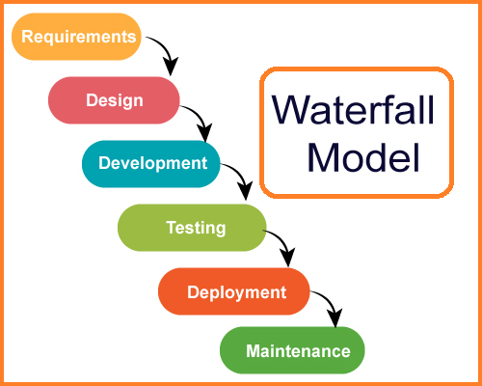

**Figure 3.1:** Waterfall Model [4]

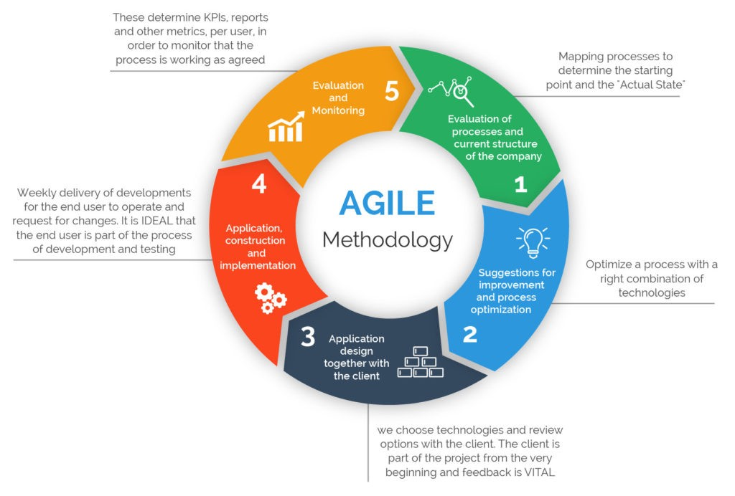**Figure 3.2:** Agile Model [5]

## 3.2 Software Development Process Life Cycle

Software development is not about the coding but each software development project must go through the following stages

* Planning
* Analysis
* Design
* Development
* Testing
* Deployment
* Maintenance

Depending on the requirements of the software project, further steps and phases may be necessary. Before a software project is officially published, the product should go through different cycles during the test phase we must find the problems and bugs and the developers should fix them.

**CHAPTER 4**

## PROJECT DESIGN

### 4.1 Overview

During my short time internship period I have worked for an ecommerce application for developing this application we choose React js which is a JavaScript library for building user interfaces.

### 4.2 Why React

With React, developers can build large web applications that change data without having to reload the page. The main purpose of React is to be fast, scalable and easy. It only works on user interfaces in the application. For this reason React.js is the most popular front-end framework for web application developers.

4.2 Project Functionalities

* A customer can register on the site.
* A customer can login on the site.
* A customer can view his profile.
* A customer can edit his profile.
* A customer can see all product.
* A customer can search for a specific product
* A customer can add products on cart.
* A user can check out on the site.

**4.2 Use Case diagram for the project**

Figure 4.1 shows the Use Case Diagram of this project.

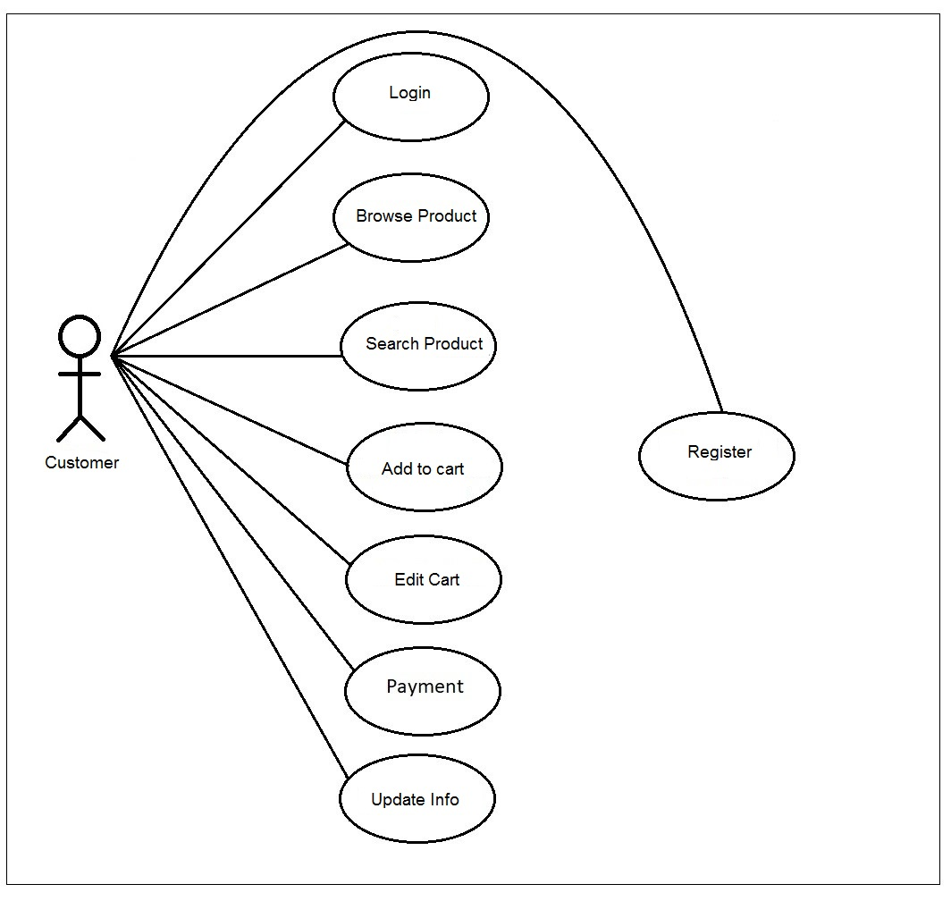

Figure 4.1: Use Case diagram

### 4.3 Class Diagram for the project

Figure 4.2 shows the Class Diagram of the user panel of this project.

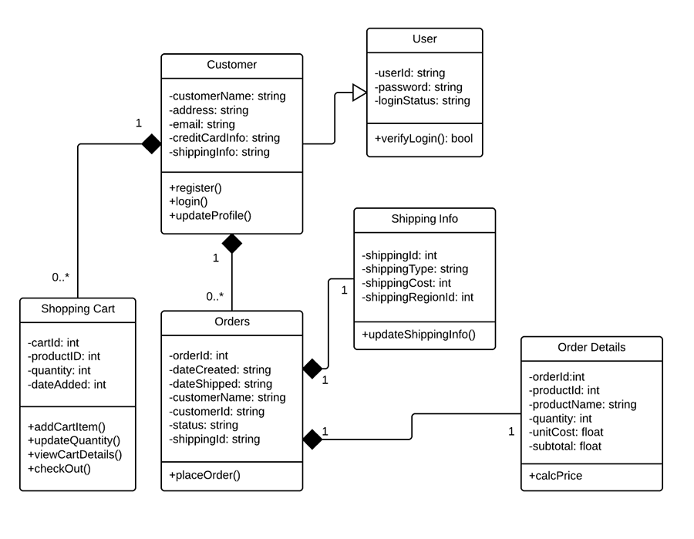

Figure 4.2: Class diagram

### 4.4 Implementation

4.3 shows the home page of this project.

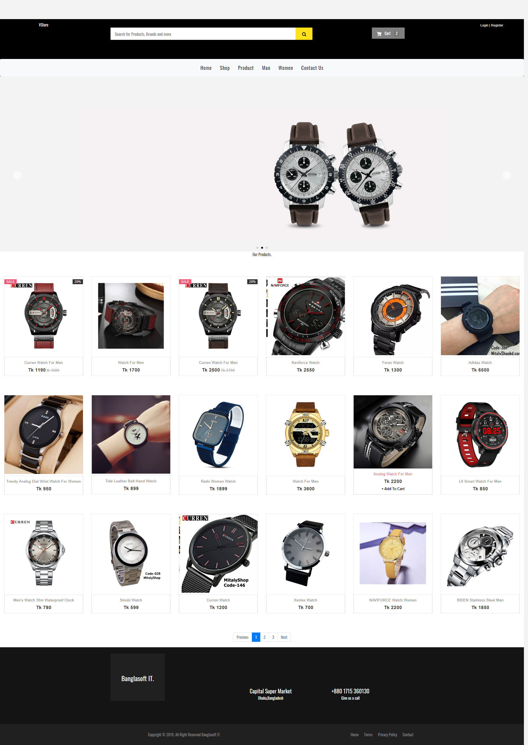

Figure 4.3: Home Page

This is the header (Figure 4.4 ) of our project which contain a company logo at the left corner and the login & registration button on the right corner. In the middle there is a filterable search bar which help the customer to find a specific product in the store and the cart button which will help a customer to go directly to the cart page. At the bottom there is a menu which contain the home page button, the shop button, the product button and the man and women filter button and the contact page button of the site owner.



Figure 4.4: Header

The body (Figure 4.5) is the main part of this project. It contains the short view of the products of this shop. It shows the thumbnail image, the name of the product, the price and there is also add to cart button which help a customer to select their desire product and add the product to the cart page for the checkout also clicking on any product goes to the product details page.

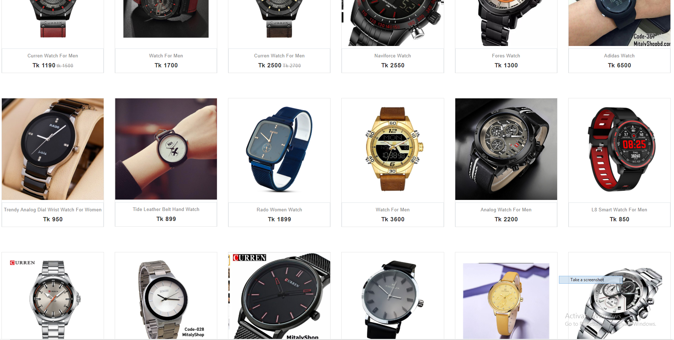

Figure 4.4: Body

The Footer (Figure 4.6 ) is the bottom of any web page.Here we can see a pagination which help a user to go to the next page to find more data it also help to go back to previous page and it also contain the company info and the button to go the terms & privacy pages.

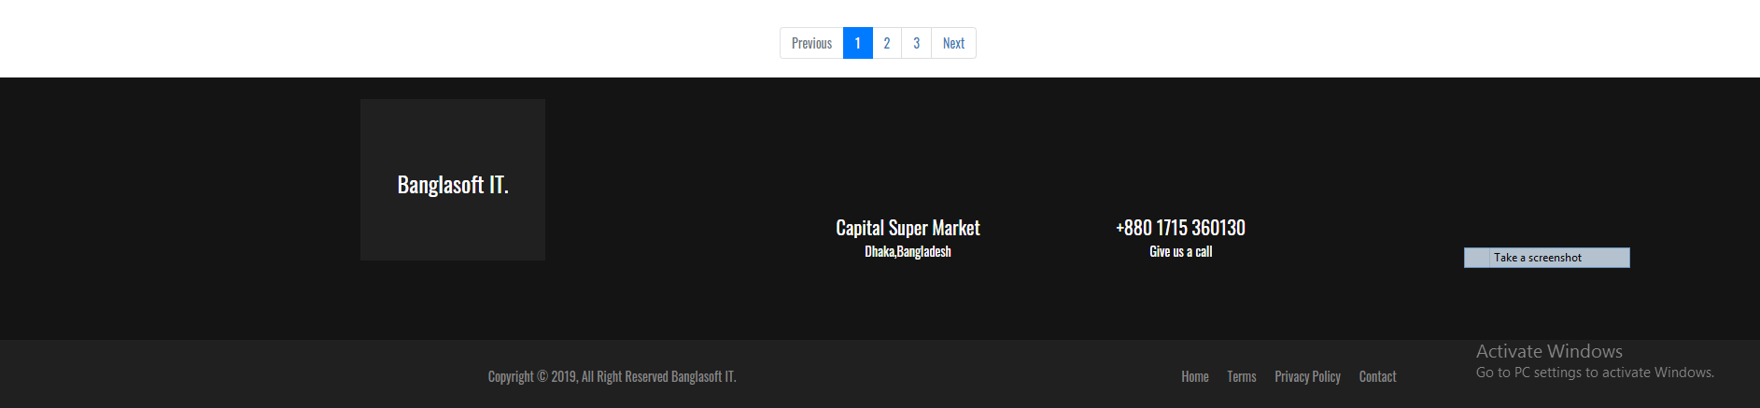

Figure 4.6: Footer

This is the registration page (Figure 4.7) for this site. If a customer want to register himself as a member of this site he just need to fill out the form and hit the submit button and then he will be a registered member of this site and his data will be saved for completing the checkout process.

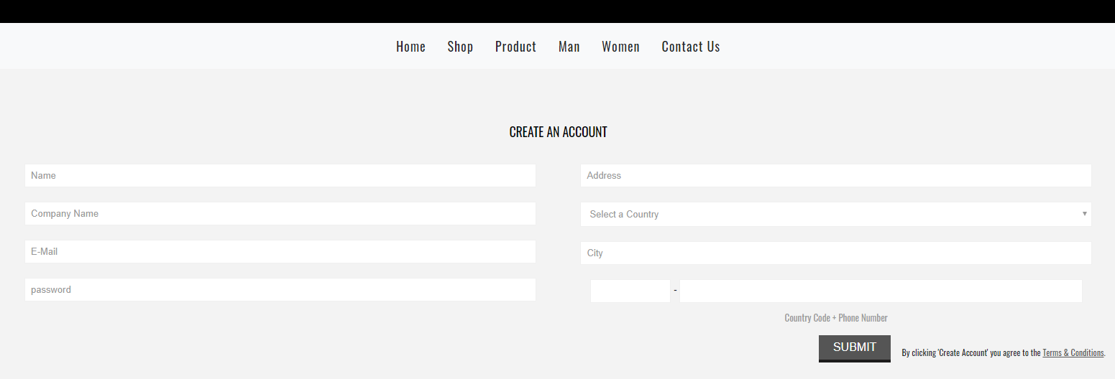

Figure 4.7: Registration Page

An existence member can easily logged into the site for completing the checkout process by submitting his username and password into the form showing into the login page (Figure 4.8) . After login he don’t need to fill up the checkout from because his data will be automatically fill by the system and he can easily process his order.

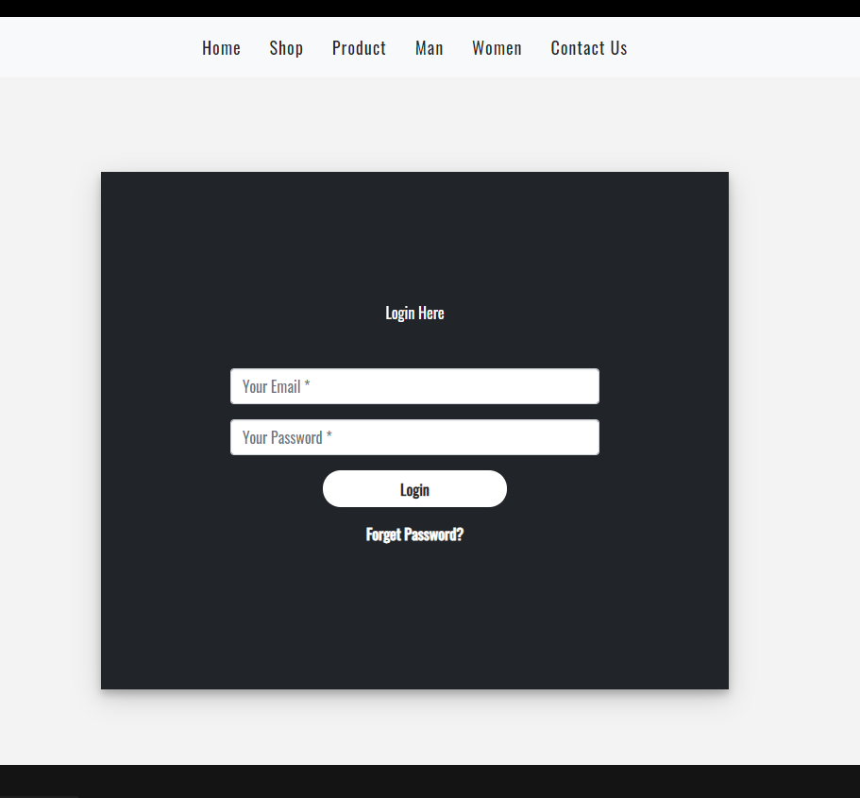

Figure 4.8: Login Page

This is the product details page (Figure 4.9) here a customer can see the brief description and all other specification of the product by clicking on any product from the main page this details page will come for that particular product here customer can select the quantity of order and then he can add the product on cart by clicking the add to cart button.

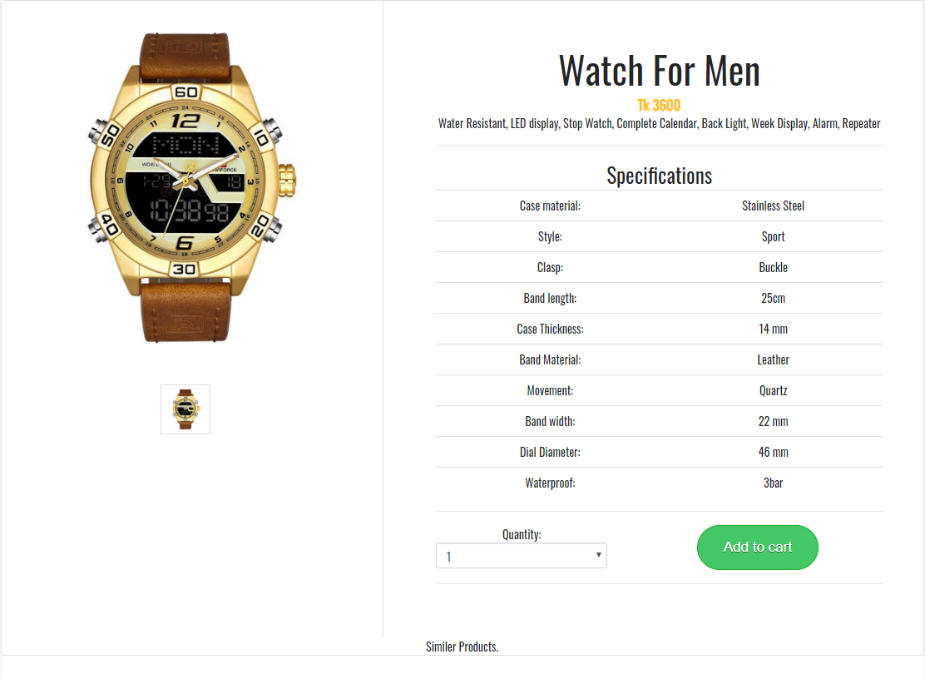

Figure 4.9: Product Details

This is the cart page (Figure 4.10) of this web site basically a cart page store that product information which the customer select for the check out. Here he can also edit the cart data and also remove any product which he don’t want to check out.

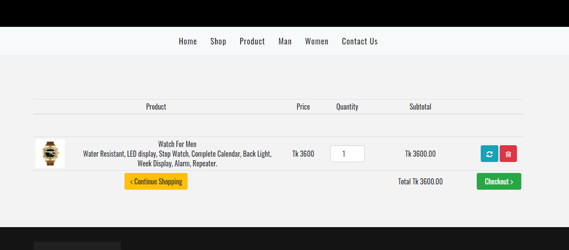

Figure 4.10: Cart page

Checkout is the final stage of any echommerce site. In the checkout page (Figure 4.11) a customer have to fill out the form for completing the checkout process for that he need to fill his first name, last name, his present address where he want to receive the product and finally need to press the button confirm order button and his order will be confirmed.

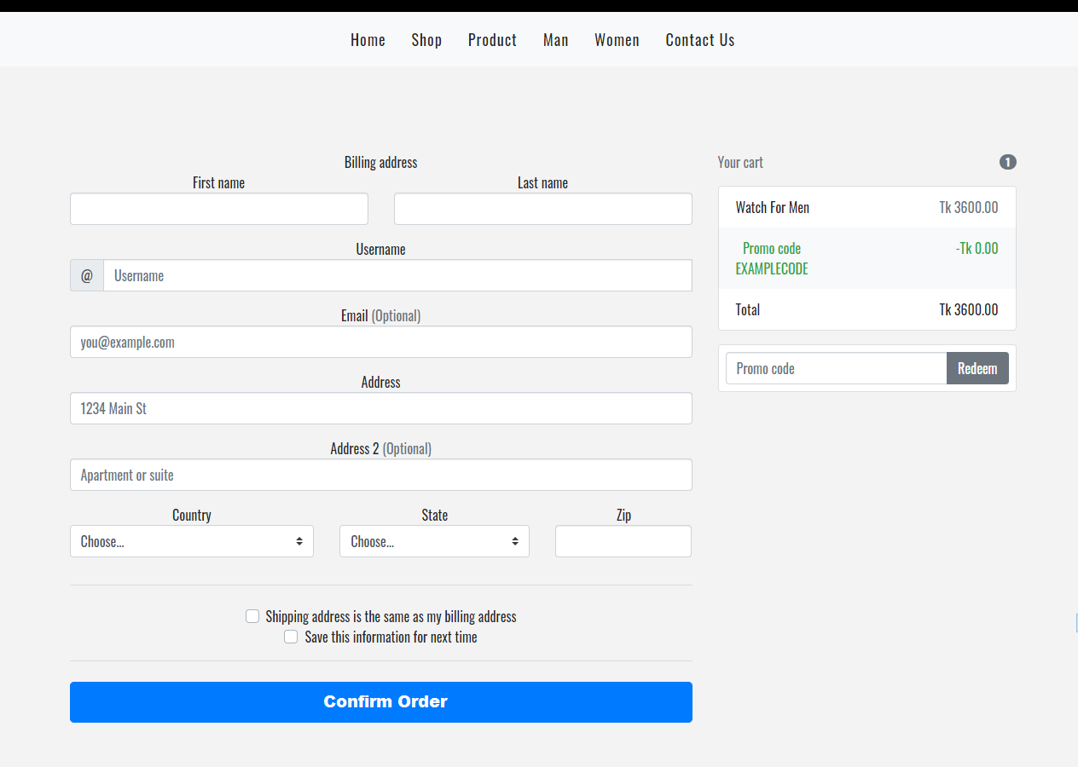

Figure 4.11: Checkout page

### 4.5 Database Structure

Figure 4.12 shows the database structure of the project.

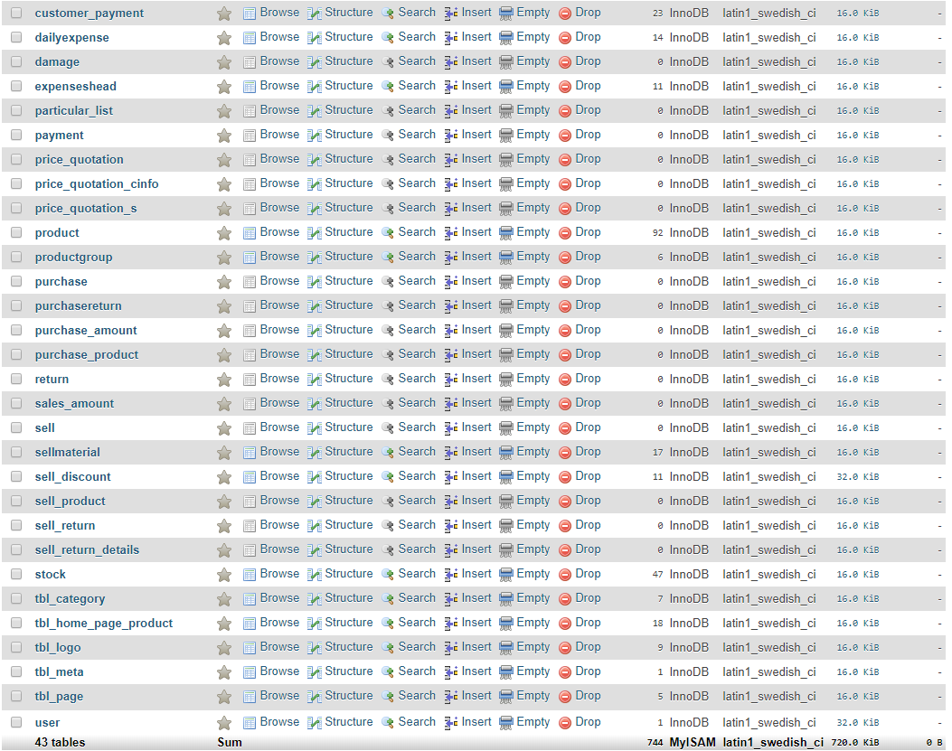

Figure 4.12: Database Structure

Figure 4.13 shows the user table structure of the project.

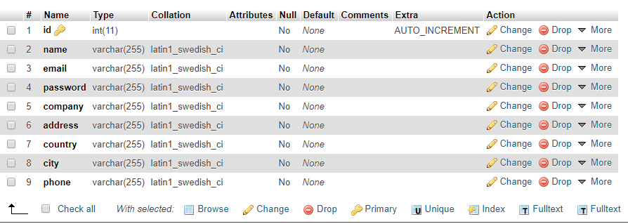

Figure 4.13: User Table Database Structure

Figure 4.14 shows the cart table structure of the project.

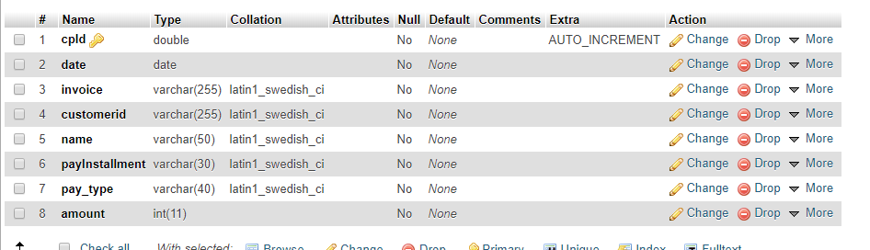

Figure 4.14: Cart Table Database Structure

**CHAPTER 5**

## CONCLUSION

Working on a real life project in the software industry was very interesting for me. Being an intern at Bangla soft computer was a new and very exciting experience in my life. I always try to get to know and observe the work system and the goal of the company. The internship here has increased my technical and development skills. I have gradually changed my career. My company and superiors are very helpful to me. Without their exceptional support, I couldn't get the right knowledge about professional work properly.

During my internship period I have learned practical knowledge about web application development with react js. Now I can develop any web application with my experience. This internship help me a lot for my future career. It was a good experience for me to work with bangla soft computer.

**REFERENCE**

[1] “Company profile”, Banglasoftcomputer.[Online].

Available:[http://banglasoftcomputer.com/v1.[Accessed](http://microdeft.com/.%5bAccessed): 19-April-2020].

[2] “Mission”, Banglasoftcomputer.[Online].

Available: [http://banglasoftcomputer.com/v1.[Accessed](http://microdeft.com/.%5bAccessed): 19-April-2020].

[3] “Vision”, Banglasoftcomputer.[Online].

Available: [http://banglasoftcomputer.com/v1.[Accessed](http://microdeft.com/.%5bAccessed): 19-April-2020].

[4] “Waterfall Model”, Available: [http:// netnic.org/waterfall-model-of-software-engineering.[Accessed](http://microdeft.com/.%5bAccessed): 19-April-2020].

[5] “Agile Model”, Available:http:// medium.com/@sudarhtc/agile-project-management-methodology-manifesto-frameworks-and-process-f4c332ddb779.[Accessed: 19-April-2020].